1. <https://github.com/eazybytes/openapi/blob/main/openapi-yaml-examples/openapi_04.yml>
2. 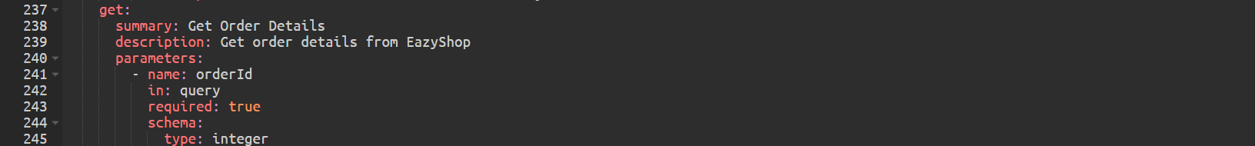
3. A screenshot of a computer

   Description automatically generatedA black rectangle with white text

   Description automatically generatedA white rectangular object with a black line

   Description automatically generatedA white rectangular object with a black border

   Description automatically generated
4. A black rectangular object with white text

   Description automatically generated